WIRESHARK LAB 6

Part 1: Basic

- Select the first UDP segment sent by your computer via the traceroute command to gaia.cs.umass.edu. (Hint: this is 44th packet in the trace file in the ip- wireshark-trace1-1.pcapng file in footnote 2). Expand the Internet Protocol part of the packet in the packet details window. What is the IP address of your computer?
Answer
108.177.96.104
- What is the value in the time-to-live (TTL) field in this IPv4 datagram’s header?
Answer
56
- What is the value in the upper layer protocol field in this IPv4 datagram’s header? [Note: the answers for Linux/MacOS differ from Windows here].
Answer
(0x0800)
- How many bytes are in the IP header?
Answer
20 Bytes
- How many bytes are in the payload of the IP datagram? Explain how you determined the number of payload bytes.
Answer
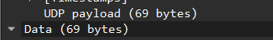
I check the Data Header, and see the length of the field. In this example the field is 69 in length, meaning it will take up 69 bytes

- Has this IP datagram been fragmented? Explain how you determined whether or not the datagram has been fragmented.
Answer
The date is not fragmented. It only has one encrypted field, with a length of 69.

- Which fields in the IP datagram always change from one datagram to the next within this series of UDP segments sent by your computer destined to 128.119.245.12, via traceroute? Why?
Answer
The identification field is always changing between the series of UDP segments. No. 44 segment, has identification 0xfda1, while No.48 segment has identification 0xfda2. The header checksum is also changing. No. 44 is 0x2faa while No.48 is 0x2fa9. Time to live changes every fourth segment.
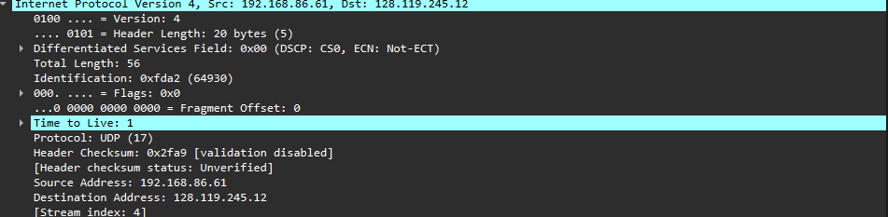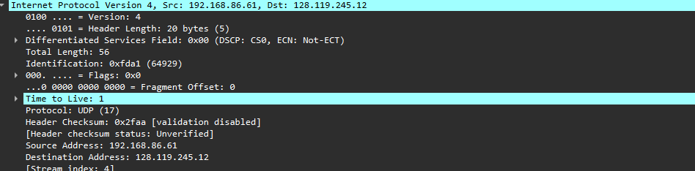

- Which fields in this sequence of IP datagrams (containing UDP segments) stay constant? Why?
Answer
IP Version, Header Length, Type of Service, Protocol, Source IP Address, Destination IP Address, and Total Length and Flags/Fragment Offset

These fields describe the structure and endpoints of communication, which don’t change from one probe to the next, only control-related values (TTL, ID, checksum, ports) vary.

- Describe the pattern you see in the values in the Identification field of the IP datagrams being sent by your computer.

Answer
The identification field values in the IP datagrams increase in a regular pattern. Usually by one for each successive datagram. This reflects the host’s method of assigning a unique ID to every packet it sends.

- What is the upper layer protocol specified in the IP datagrams returned from the routers? [Note: the answers for Linux/MacOS differ from Windows here].
Answer
The upper-layer protocol is the Internet Control Message Protocol, because we are using the Windows operating system.
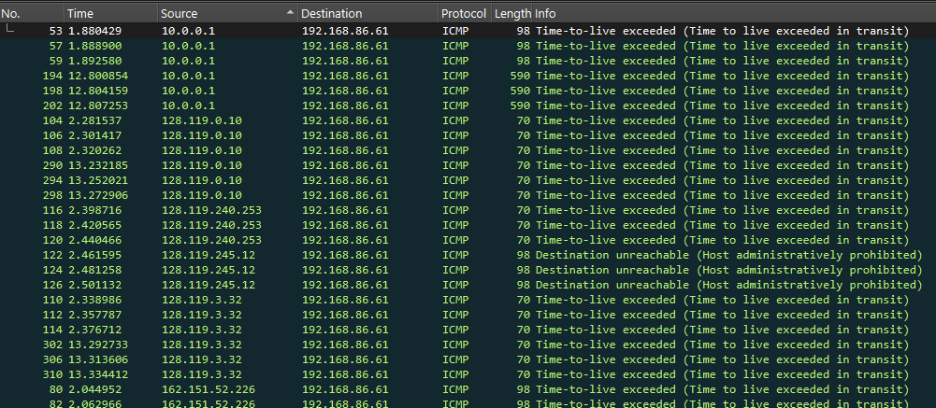

- Are the values in the Identification fields (across the sequence of all of ICMP packets from all of the routers) similar in behavior to your answer to question 9 above?
Answer
Yes, it is very similar. The identification changes with the increment of 1, just like in question 9, and the header checksum. But the time to live does not change. It is always 1.

- ​Are the values of the TTL fields similar, across all of ICMP packets from all of the routers?

Answer
Yes, the values of the TTL fields are similar across all of ICMP packets. Their value is 1.

Part 2: Fragmentation
- Find the first IP datagram containing the first part of the segment sent to 128.119.245.12 sent by your computer via the traceroute command to gaia.cs.umass.edu, after you specified that the traceroute packet length should be 3000. (Hint: This is packet 179 in the ip-wireshark-trace1-1.pcapng trace file in footnote 2. Packets 179, 180, and 181 are three IP datagrams created by fragmenting the first single 3000-byte UDP segment sent to 128.119.145.12). Has that segment been fragmented across more than one IP datagram? (Hint: the answer is yes⁴!)
Answer

Yes, the 179 segments have been fragmented across more than one IP datagram.
The IP protocol tells us that it is fragmented.

- What information in the IP header indicates that this datagram been fragmented?
Answer
The ip.flags shows us that there are more fragments. In this case there are 3 other fragments.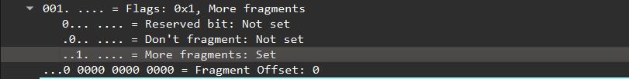

- What information in the IP header for this packet indicates whether this is the first fragment versus a latter fragment?
Answer
The 179 segment has offset of 0, which means that it is the first fragment
The 180 segment has offset of 1480, which means that it is the second fragment
The 181 segment has offset of 2960, which means that it is the third fragment

- How many bytes are there in is this IP datagram (header plus payload)?
Answer
The header length of the IP datagram is 20 bytes, and the payload is 1480 bytes. In total that would be 1500 bytes.
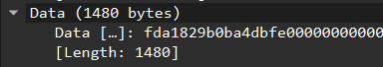

- Now inspect the datagram containing the second fragment of the fragmented UDP segment. What information in the IP header indicates that this is not the first datagram fragment?
Answer
Same as the answer for 15, we can look for the Fragment Offset. When the fragment offset says 0, then that is the first fragment.

The 179 segment has offset of 0, which means that it is the first fragment
The 180 segment has offset of 1480, which means that it is the second fragment
The 181 segment has offset of 2960, which means that it is the third fragment

- What fields change in the IP header between the first and second fragment?
Answer
Header checksum, ip.frag_offset, and ip.fragments is an extra field that appears at the last fragment.

- Now find the IP datagram containing the third fragment of the original UDP segment. What information in the IP header indicates that this is the last fragment of that segment?
Answer
The last fragment has an extra header called ip.fragments. This shows all the fragments, and what their position is. The first being 179, then 180 and lastly 181.
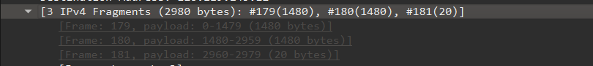

Part 3: IPv6

- What is the IPv6 address of the computer making the DNS AAAA request? This is the source address of the 20th packet in the trace. Give the IPv6 source address for this datagram in the exact same form as displayed in the Wireshark window⁵.
Answer

- What is the IPv6 destination address for this datagram? Give this IPv6 address in the exact same form as displayed in the Wireshark window.
The IPv6 destination address is: 2001:558:feed::1
Answer

- What is the value of the flow label for this datagram?
Answer
The value of the flow label for the datagram is: 0x063ed0

- How much payload data is carried in this datagram?
Answer
The payload is carrying 37 payload data.

- What is the upper layer protocol to which this datagram’s payload will be delivered at the destination?
Answer
The upper layer protocol is the UDP.

Lastly, find the IPv6 DNS response to the IPv6 DNS AAAA request made in the 20th packet in this trace. This DNS response contains IPv6 addresses for youtube.com.

- How many IPv6 addresses are returned in the response to this AAAA request?
Answer
The response for 20th packet, is the 27th packet, with one answer.

What is the first of the IPv6 addresses returned by the DNS for youtube.com (in the ip-wireshark-trace2-1.pcapng trace file, this is also the address that is numerically the smallest)? Give this IPv6 address in the exact same shorthand form as displayed in the Wireshark window.

Answer

youtube.com: type AAAA, class IN, addr 2607:f8b0:4006:815::200e

